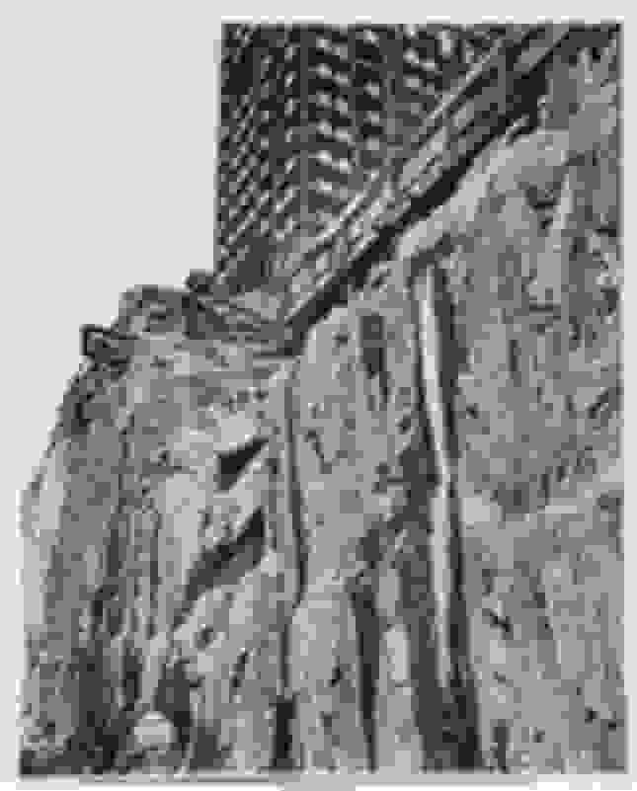
Abbott took this image of the foundations of the Rockefeller building in 1932, Abbott was able to capture the foundations of this iconic building which would go on to become a staple of New York, the construction of this building helped provide work for thousands of people during the great depression and stock market crash where unemployment rates and poverty were at an all-time high, so for some working on the building, it was an almost life changing experience. Abbot managed to capture the rising building by using an extremely low angle looking upward into the unfinished parts of the building.
This is another still image taken by Berenice Abbott in the city of New York for her ‘Changing New York’ series, however how Abbott took this image is directly oppositional to how she portrayed west side Manhattan in the ‘Nightview’ in the same series as in that image Abbot was at the peak of the Empire state building looking down but in this image Abbott is at the foundations of the building looking upwards to the sky, having a contrast as drastic as this in 2 images in the same project shows Abbotts range of work in capturing the construction of what would go on to be an iconic building and a staple of New York in the present day.
Abbott rarely if not never manipulated photos after taking them as she was a firm believer in ‘straight photography’ which like the name suggests is just the unfiltered and unedited photograph as it was taken. “What the human eye observes casually and incuriously the eye of the camera notes with relentless fidelity.”- this quote from Abbott supports her view on keeping images unedited and as raw as we see something with our eyes. Abbott most likely used a large format camera to capture the intrinsic details where the rock meets the foundations of the building, the monotone colour used makes the cliff blend into the foundations and the rest of the building. The only contrast is the busy foreground with the details of the cliff, foundations and the buildings and the clear skies in the background.
The low camera angle makes the building seem taller and imposing to the viewer as it highlights the buildings real height compared to others surrounding it. The smooth different shades of grey make the viewer feel as if the photo is as clear as seeing the building with your own eyes as everything manages to be clear and in focus almost making it seem as if the photo was taken in modern times.

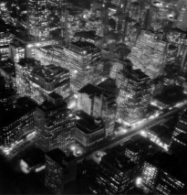
‘The Night view’ is a still image that was taken by Berenice Abbott in 1932 from the Empire state building for her project ‘Changing New York. Abbott used harsh contrasts to make the image stand out more, the images main colours are black and white with slight hints of grey which is what creates said contrasts between buildings and its lights, Abbott was an American photographer who was best known for her intentional black and white images of New York City and portraits of cultural figures such as French writer James Joyce and fellow photographer and later her mentor Eugene Atget.
Abbot planned this shot of Manhattan by waiting for the shortest day of the year and she waited for the small window where offices and work buildings alike would still have their lights on, despite it being completely dark outside. This difference in hues creates a soft natural light pattern covering the strongly contrasting shadowy buildings. Despite the image being in black and white, there are many different shades of grey made by the powerful contrasts between the buildings and their lights blending together. The peaks of the buildings are visible to the viewer in sharp quality; however, the roads and the bases of the buildings are slightly blurred making them a lesser focus of the image. The overlapping buildings make the centre of the image look and feel congested. Abbotts use of a dramatic high angle makes the buildings seem almost like miniature replicas, this. displays the height of the Empire State building is compared to the rest of the buildings around it at the time.
Abbott took this north facing picture of the west side of Manhattan as part of one of her larger projects ‘Changing New York’ where she wanted to document New York’s rapid development into modernity and its present state. Abbott took the shot at an angle where the buildings are almost arranged in a grid pattern reflecting the modernist way of portraying art in straight lines and simple designs, however the patterns created by the lights make the shot look more dramatic and complex like a computer system which ties back to the modernising New York. This image and others in Abbotts ‘Changing New York’ focus on the rapid industrialisation of the city. This is shown as even through the depression and mass unemployment the city’s development did not stop or slow down.
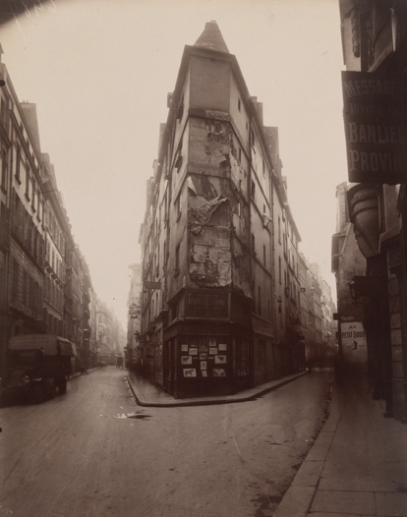
The ‘Rue de Sein’ is a picture taken by French photographer Eugene Atget who was best known for his surreal large-scale projects of buildings in Paris, Atget specialized in making audiences feel nostalgia and melancholy. This image is a good example of the work that Atget is typically known for.
This is a low shot of an unusually shaped building in Paris’ left bank by taking the image at this angle Atget was able to make the building look imposing as it almost fully towers over the camera, this could make viewers feel in awe or worry. Atget reportedly used a large tripod and slow exposures of the early morning to produce the hazy fog seen in the image.
This style of ‘large scale photography’ heavily influenced Abbot’s work in later years as seen by the similarities in her ‘Changing New York’ series. Abbott uses a similar method of photography when she takes a picture of the previously discussed ‘Rockefeller Centre’ as she takes the photo from a low camera angle similar to this image.

