Personal Study Plan
Define the objective or focus of the essay:
-Berenice Abbott/ pictures of gentrified New York/great depression/contrasts the beautiful cityscape that Abbott highlighted
-I will investigate how Abbott managed to catch the city of New York in such an amazing still despite the tensions during the time This being the great depression which was from 1929 to 1939
-Berenice Abbott developed Macro Photography in the 1940s, which is extreme close-up photography in which the subject is reproduced at greater than its actual size. (Source https://en.wikipedia.org/wiki/Macro_photography)
- Joel Meyerowitz
The relationship between the practical work and the focus of the study:
-Night shots
-Shots of buildings
-I am planning to get nighttime pictures of buildings in local areas to try and imitate Abbott’s night picture of new York city
-I will also try to get extremely high and low angled shots of buildings to imitate Aget and Abbott’s shots
Sources to be used:
Books (at least THREE): | Websites: | Other sources:
-Berenice Abbott: A life in photography  -Eugene Atget: Old Paris  -Berenice Abbott: New York in the thirties | https://theimagecentre.ca/collection/berenice-abbott-archive/  https://uk.lumas.com/artist/berenice_abbott-1/?srsltid=AfmBOopyHyZI9ilb_Lr4ueb7gLMzO83LBYRbLaseUSsEGV6Z5qqVy5fq  https://www.moma.org/artists/41-berenice-abbott

List the pieces of work that you will analyse in the study. Identify reasons for choosing these particular pieces and points that may be highlighted in the analysis. Mark the primary source/s with *
Name of piece: | Reasons for choice/Points to be raised:
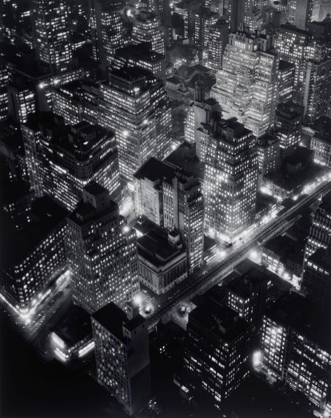  ’Nightview’  B Abbott 1932  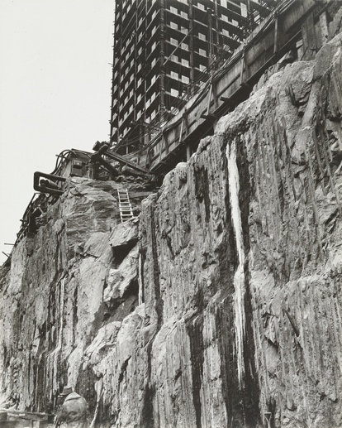  ’Rockefeller Centre’  B Abbott 1932  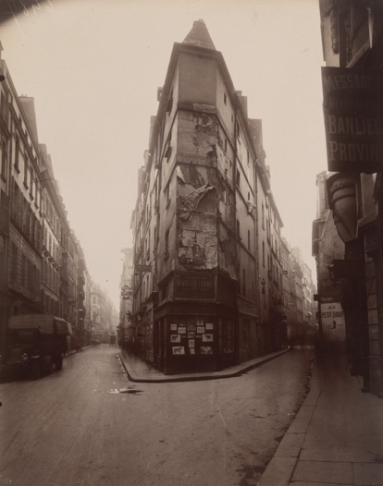  ‘Rue de Seine’  E Atget 1924  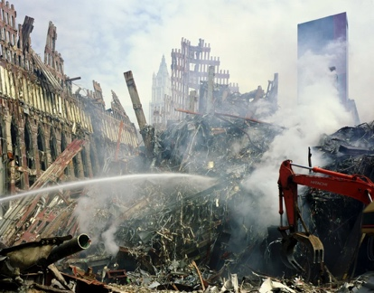  ‘Aftermath- World Trade Centre’  J Meyerowitz | This photograph is one of the most celebrated from Abbotts career. I will discuss how in this image we are able to see the social and economic growth within New York City in the early 30s.  This image depicts the foundations of the iconic Rockefeller Centre and how New York was thriving at the time as Abbitt was able to capture the foundations of what would go on to become a staple of New York, the angle this is taken at also directly contrasts Abbot’s ‘Nightview’ as that photo is taken at the peak of the Empire State building looking down, whereas this is taken at the base looking up.  Agets influence on Abbotts work is shown through their similar use of angles to make a building seem bigger and more intimidating an example of this in Abbotts work would be how she angles her photo of the ‘Rockefeller Centre’ using the same low angle as Aget used to capture this image.  This image displays the impact of the attack on the world trade centre’s in 2001 Meyerowitz uses far stabilized shots to capture the destruction of the Trade Centre.
Visit/s made/to be made:
Trip to Salford/Lowry on the 2nd of Oct
Possible conclusion/s to the study:

